|  |  |
| --- | --- |
| **EXP NO:01** |  |
| **DATE:** |

AIM:

ALGORITHM:

SOURCE CODE:

import cv2  
  
  
def main():  
 image = cv2.imread("C:\\Users\\CSE\\Pictures\\Screenshots\\hi.png")  
 if image is None:  
 print("error:could not read the image")  
 return  
 res_image = cv2.resize(image, (500, 500))  
 cv2.imwrite("resized_image.jpg", res_image)  
 print("resized image saved")  
 cv2.imshow("original image", image)  
 cv2.imshow("resized image", res_image)  
 cv2.waitKey()  
 cv2.destroyAllWindows()  
  
  
if __name__ == "__main__":  
 main()

OUTPUT:

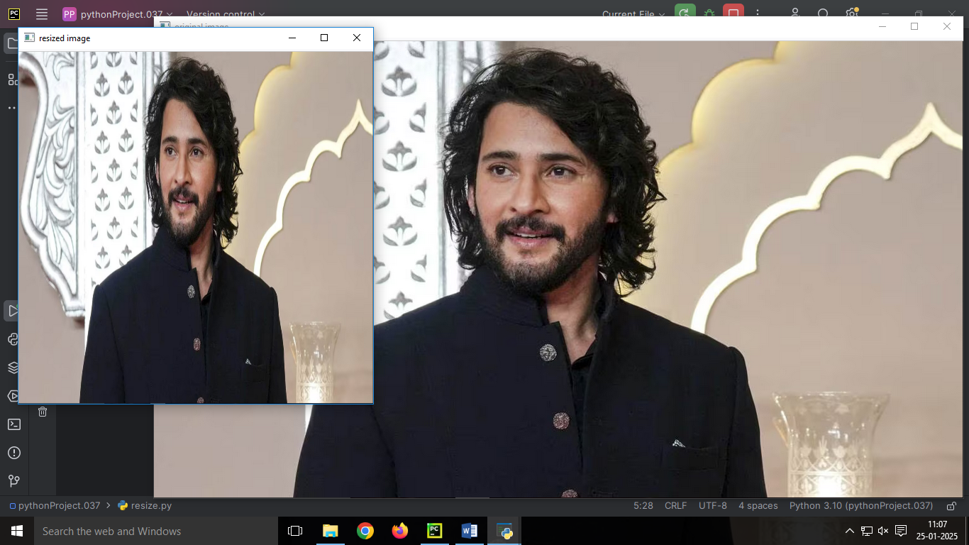

RESULT:

|  |  |
| --- | --- |
| **EXP NO:02** |  |
| **DATE:** |

AIM:

ALGORITHM:

SOURCE CODE:

import cv2  
  
  
def main():  
 image = cv2.imread("resized_image.jpg")  
 if image is None:  
 print("error:could not read the image")  
 return  
 gray_image = cv2.cvtColor(image,cv2.COLOR_BGR2GRAY)  
 hsv_image=cv2.cvtColor(image,cv2.COLOR_BGR2HSV)  
 cv2.imshow("Orginal image", image)  
 cv2.imshow("gray image",gray_image)  
 cv2.imshow("hsv image",hsv_image)  
 cv2.waitKey()  
 cv2.destroyAllWindows()  
  
  
if __name__ == "__main__":  
 main()

OUTPUT:

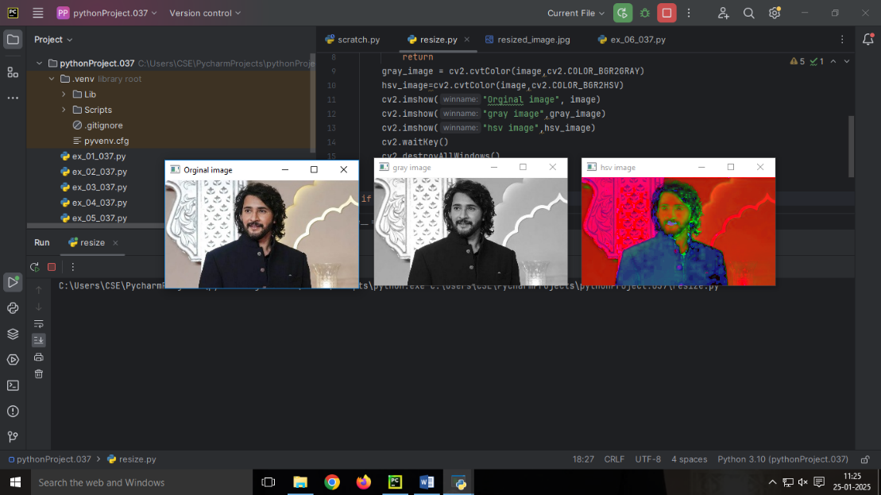

RESULT:

|  |  |
| --- | --- |
| **EXP NO:3** |  |
| **DATE:** |

AIM:

ALGORITHM:

SOURCE CODE:

import cv2  
import numpy as np  
image = np.ones((500,500,3),dtype='uint8')* 255  
cv2.line(image,(50,50),(450,450),(0,0,255),5)  
cv2.circle(image,(250,250),100,(0,255,0),3)  
cv2.rectangle(image,(50,400),(450,450),(255,0,0),-1)  
cv2.rectangle(image,(100,100),(400,450),(0,255,255),5)  
cv2.imshow('image',image)  
cv2.waitKey()  
cv2.destroyAllWindows()

OUTPUT:

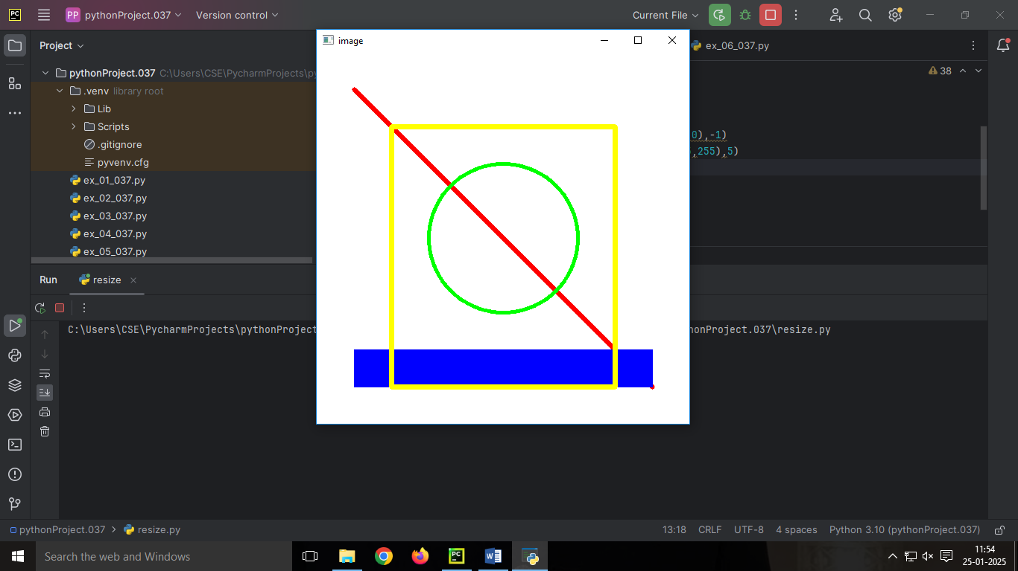

RESULT:

|  |  |
| --- | --- |
| **EXP NO:4** |  |
| **DATE:** |

AIM:

ALGORITHM:

SOURCE CODE:

import cv2  
from PIL import Image  
image = cv2.imread('resized_image.jpg')  
print("IMAGE HEIGHT:",image.shape[0])  
print("IMAGE WIDTH:",image.shape[1])  
print("NUMBER OF CHANNELS",image.shape[2])  
print("IMAGE SIZE:(IN PIXELS)",image.size)  
print("IMAGE DATA TYPE:",image.dtype)  
image=Image.open('resized_image.jpg')  
print("image Format",image.format)

OUTPUT:

IMAGE HEIGHT: 168

IMAGE WIDTH: 300

NUMBER OF CHANNELS 3

IMAGE SIZE:(IN PIXELS) 151200

IMAGE DATA TYPE: uint8

image Format JPEG

RESULT:

|  |  |
| --- | --- |
| **EXP NO:5** |  |
| **DATE:** |

AIM:

ALGORITHM:

SOURCE CODE:

import cv2  
image = cv2.imread('resized_image.jpg')  
res_img=cv2.resize(image,(400,350))  
text='MAHESH:'  
position=(30,50)  
font=(cv2.FONT_HERSHEY_SIMPLEX)  
font_scale=1  
color=(255,0,0)  
thickness=2  
cv2.putText(res_img,text,position,font,font_scale,color,thickness)  
cv2.imshow('image with text',res_img)  
cv2.waitKey()  
cv2.destroyAllWindows()

OUTPUT:

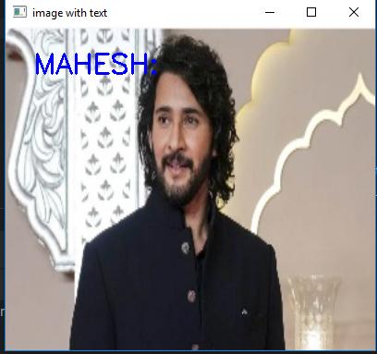

RESULT:

|  |  |
| --- | --- |
| EXP.NO: 06 |  |
| DATE: |  |

AIM:

ALGORITHM:

SOURCE CODE:

import cv2  
def read_and_display_images():  
 image_paths = [  
 'image.jpg',  
 'tank.bmp',  
 'sniper.png',  
 'bullet.tiff'  
 ]  
 for image_path in image_paths:  
 image = cv2.imread(image_path)  
 if image is None:  
 print(f"Error: Image '{image_path}' not found!")  
 continue  
 format_name = image_path.split('.')[-1].upper()  
 cv2.imshow(f"Image as {format_name}", image)  
 cv2.waitKey(0)  
 cv2.destroyAllWindows()  
read_and_display_images()

OUTPUT:

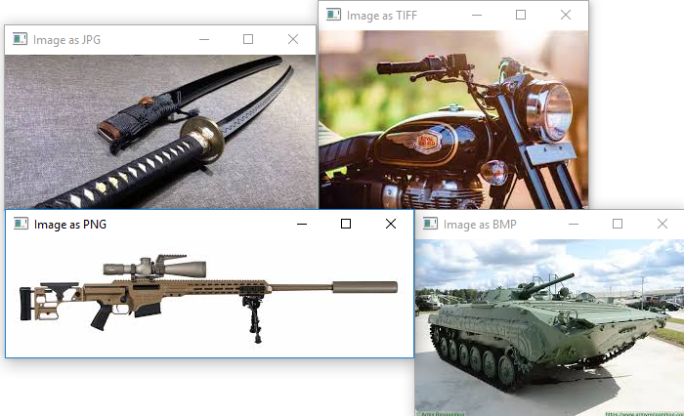

RESULT:

|  |  |
| --- | --- |
| EXP.NO: 07 |  |
| DATE: |  |

AIM:

ALGORITHM:

SOURCE CODE:

import cv2  
def read_and_display_image(image_path):  
 image = cv2.imread(image_path)  
 if image is None:  
 print("Error: Image not found!")  
 return  
 cv2.imshow("Original Image", image)  
 cv2.imwrite('output_image.png', image)  
 cv2.imwrite('output_image.bmp', image)  
 cv2.imwrite('output_image.tiff', image)  
 img_png = cv2.imread('output_image.png')  
 cv2.imshow("Image as PNG", img_png)  
 img_bmp = cv2.imread('output_image.bmp')  
 cv2.imshow("Image as BMP", img_bmp)  
 img_tiff = cv2.imread('output_image.tiff')  
 cv2.imshow("Image as TIFF", img_tiff)  
 cv2.waitKey(0)  
 cv2.destroyAllWindows()  
image_path = 'image.jpg'  
read_and_display_image(image_path)

OUTPUT:

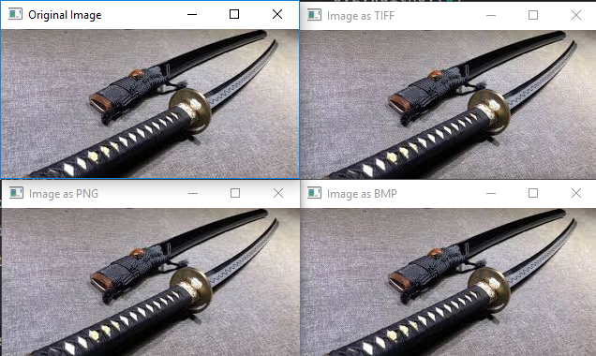

RESULT:

|  |  |
| --- | --- |
| EXP.NO: 08 |  |
| DATE: |  |

AIM:

ALGORITHM:

SOURCE CODE:

import cv2  
image = cv2.imread('bullet.tiff')  
rotated_image = cv2.rotate(image, cv2.ROTATE_90_CLOCKWISE)  
rotated_image_1 = cv2.rotate(image, cv2.ROTATE_90_COUNTERCLOCKWISE)  
rotated_image_2 = cv2.rotate(image, cv2.ROTATE_180)  
cv2.imshow("Original Image", image)  
cv2.imshow("90 Degree", rotated_image)  
cv2.imshow("-90 Degree",rotated_image_1)  
cv2.imshow("180 Degree",rotated_image_2)  
cv2.waitKey(0)  
cv2.destroyAllWindows()  
from PIL import Image  
image_path = "csk.jpg"  
img = Image.open(image_path)  
angle = 45  
rotated_img = img.rotate(angle, expand=True)  
rotated_img.show()  
rotated_img.save(f'rotated_{angle}_degrees.jpg')

OUTPUT:

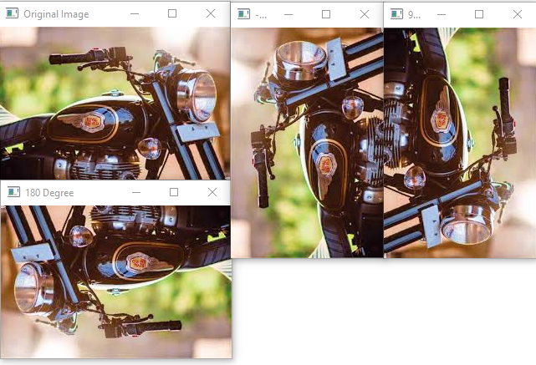

RESULT:

|  |  |
| --- | --- |
| EXP.NO: 09 |  |
| DATE: |  |

AIM:

ALGORITHM:

SOURCE CODE:

import cv2  
image = cv2.imread('tank.bmp')  
y_start, y_end = 10, 155  
x_start, x_end = 10, 155  
cropped_image = image[y_start:y_end, x_start:x_end]  
cv2.imshow('Original Image', image)  
cv2.imshow('Cropped Image', cropped_image)  
cv2.waitKey(0)  
cv2.destroyAllWindows()  
cv2.imwrite('cropped_image.jpg', cropped_image)

OUTPUT:

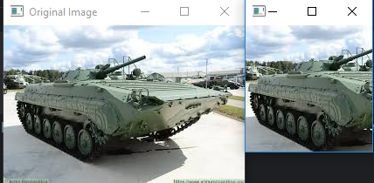

RESULT:

|  |  |
| --- | --- |
| EXP.NO: 10 |  |
| DATE: |  |

AIM:

ALGORITHM:

SOURCE CODE:

import cv2  
image = cv2.imread('image.jpg')  
flipped_horizontally = cv2.flip(image, 1)

flipped_vertically = cv2.flip(image, 0)

flipped_both = cv2.flip(image, -1)

cv2.imshow('Original Image', image)

cv2.imshow('Flipped Horizontally', flipped_horizontally)

cv2.imshow('Flipped Vertically', flipped_vertically)

cv2.imshow('Flipped Both', flipped_both)  
cv2.waitKey(0)  
cv2.destroyAllWindows()

OUTPUT:

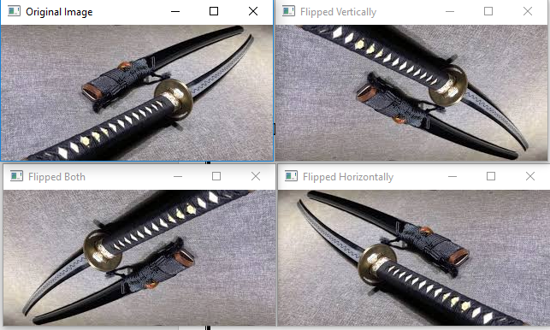

RESULT:

|  |  |
| --- | --- |
| EXP.NO: 11 |  |
| DATE: |  |

AIM:

ALGORITHM:

SOURCE CODE:

import cv2  
image = cv2.imread('sniper.png')  
cv2.imshow('Original Image', image)  
gaussian_blur = cv2.GaussianBlur(image, (5, 5), 0)  
cv2.imshow('Gaussian Blur', gaussian_blur)  
median_blur = cv2.medianBlur(image, 5) # 5x5 kernel  
cv2.imshow('Median Blur', median_blur)  
bilateral_blur = cv2.bilateralFilter(image, 9, 75, 75)   
cv2.imshow('Bilateral Filter', bilateral_blur)  
cv2.waitKey(0)  
cv2.destroyAllWindows()

OUTPUT:

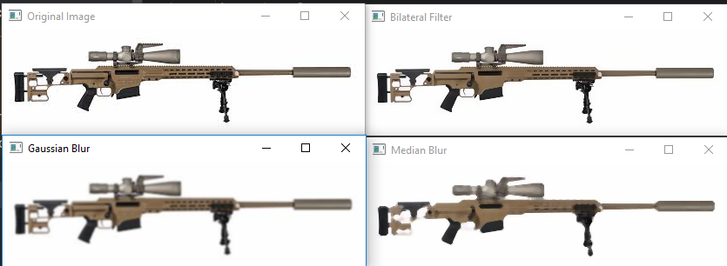

RESULT:

|  |  |
| --- | --- |
| EXP.NO: 12 |  |
| DATE: |  |

AIM:

ALGORITHM:

SOURCE CODE:

import cv2  
import matplotlib.pyplot as plt  
image = cv2.imread('bullet.tiff')  
image_gray = cv2.cvtColor(image, cv2.COLOR_BGR2GRAY)  
hist = cv2.calcHist([image_gray], [0], None, [256], [0, 256])  
plt.figure(figsize=(10, 6))  
plt.title('Grayscale Histogram')  
plt.xlabel('Pixel Intensity')  
plt.ylabel('Frequency')  
plt.plot(hist)  
plt.xlim([0, 256])  
plt.show()

OUTPUT:

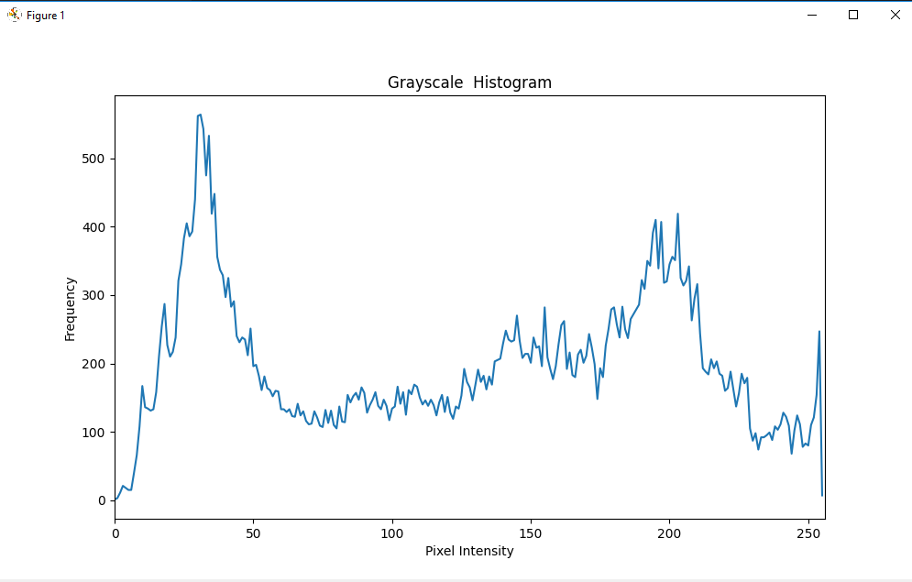

RESULT: